See What's New from PayDC!
Here’s what’s in this Release (September 30, 2022)
Patient Statements: We’ve added the Patient ID found on all Patients’ Account Screens to the Patient Statements that are accessible from the Patient Ledger at Patient Ledger > Print Statement. The Patient ID will also print on the batch Patient Statement Report at Billing > Reports > Other Reports > Patient Statements.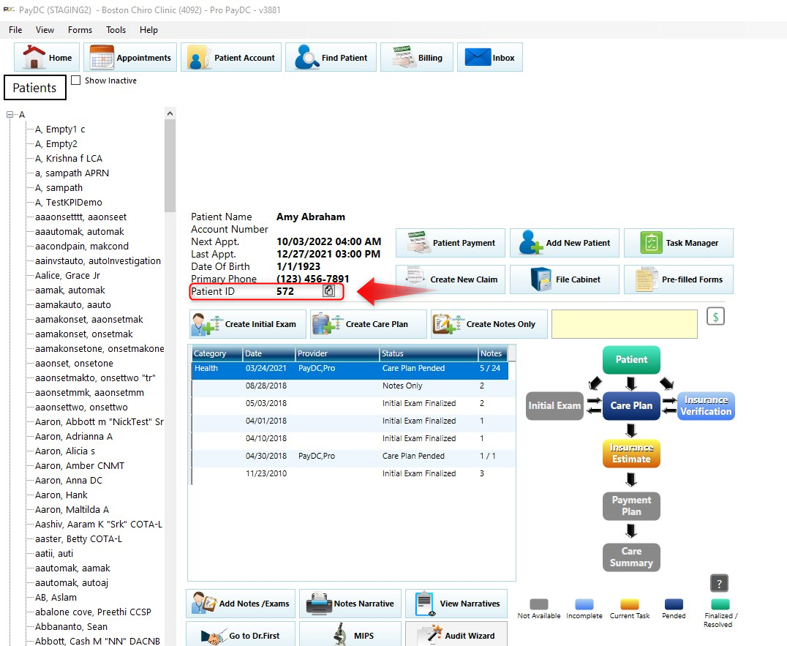
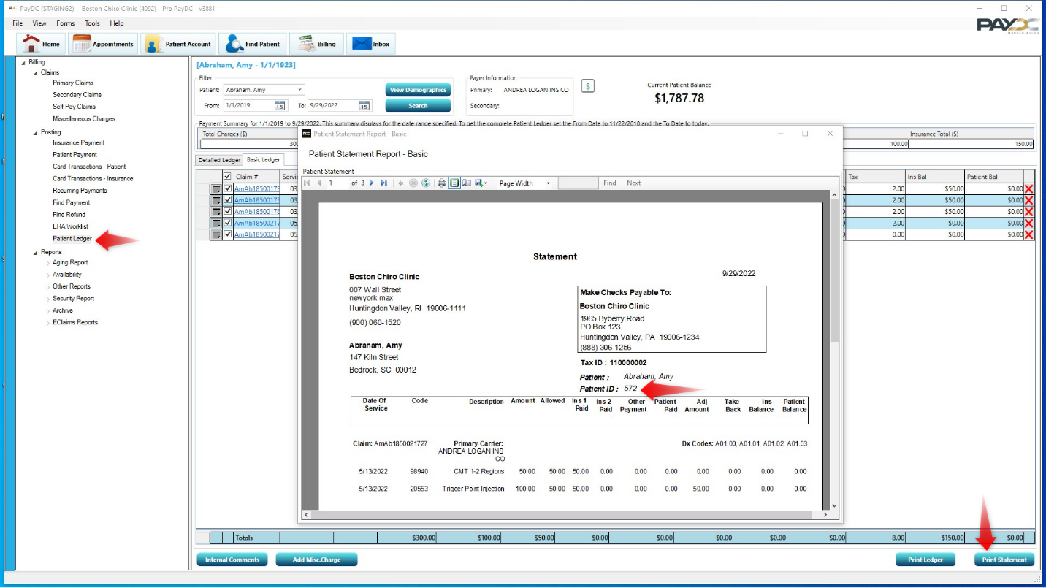

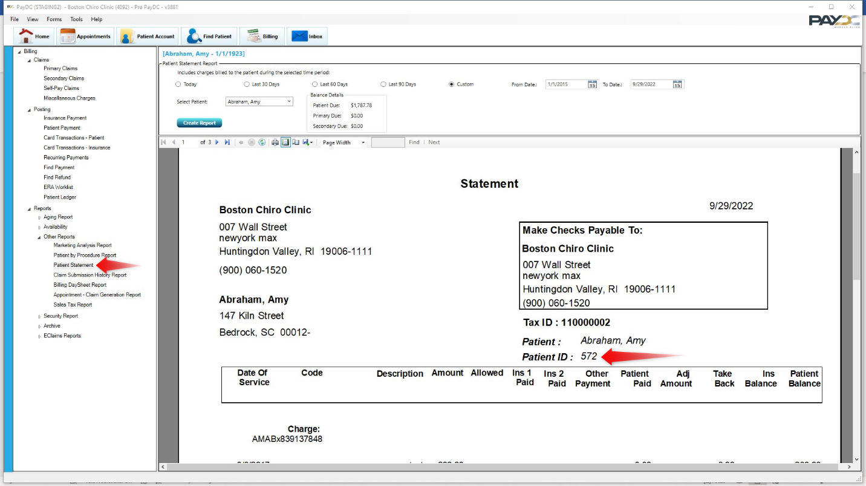

Advanced Settings: Now when Users are Inactivated, all Market Role and Administrative Role check boxes for that User will be disabled, and Inactive providers will not be shown in any of the provider drop-down fields.
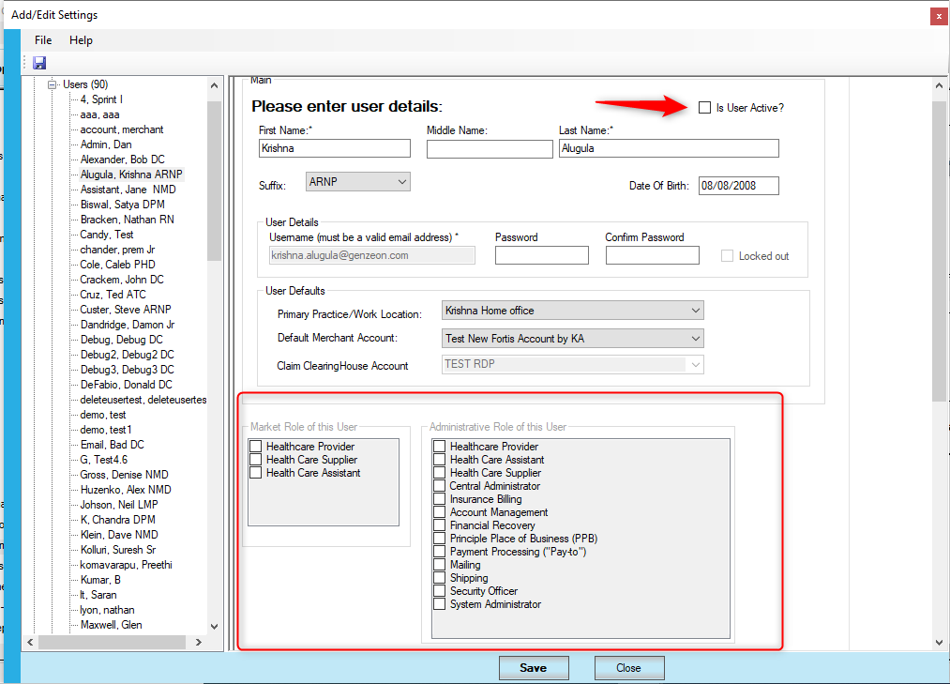

Advanced Settings: We’ve fixed the issue in Procedure Codes, to allow the user to edit the Short Description and Time Based/Unit Based check boxes even if the codes have already been used in a workflow (SOAP Note or Care Plan).
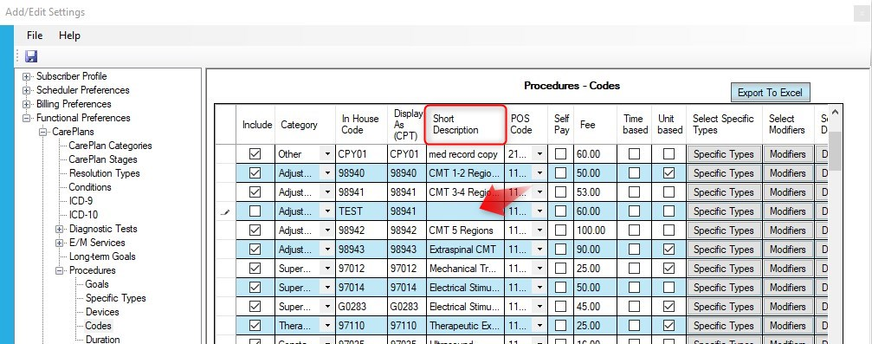

You’ll see this new alert message when editing Time Based or Unit Based check boxes for all procedure codes: Changes made to Time Based and Unit Based columns after the Procedure code has been used in Care Plans or SOAP Notes will affect existing Care Plans and SOAP Notes. Please review Care Plans utilizing the changed codes and edit accordingly.
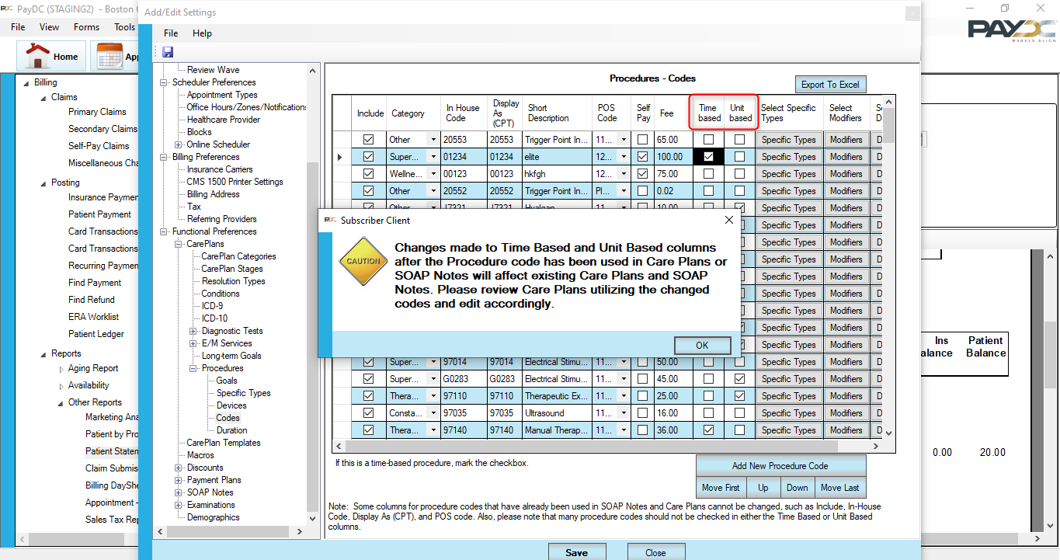
Please Note: Changing a Procedure Code to/from Unit Based, Time Based, or Neither, will affect all new workflows (Care Plans and SOAP Notes in new Notes Only workflows). But it will only affect existing Care Plans if you click Edit the Care Plan. When clicked, the revised procedure codes in the Plan will default to 1 unit. This will affect the Care Plan Narrative and the Care Plan Cost Summary. Please edit these defaulted unit values in these Plans accordingly.
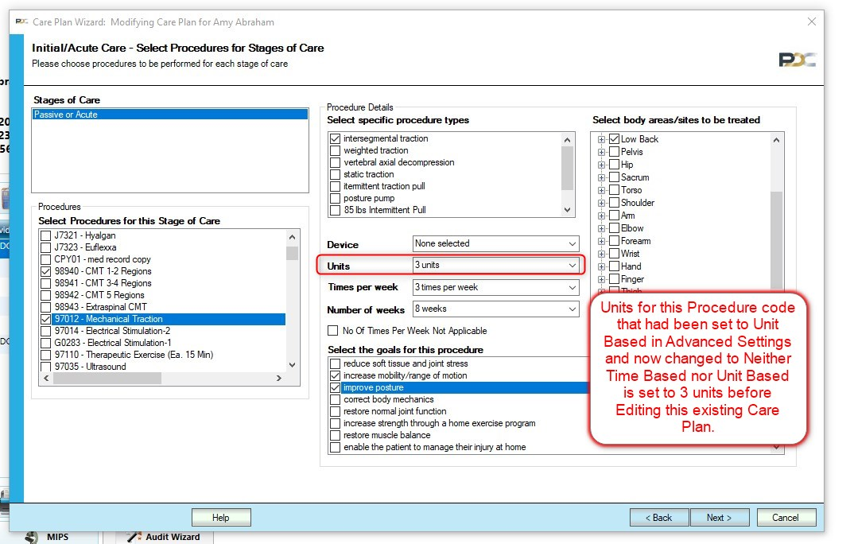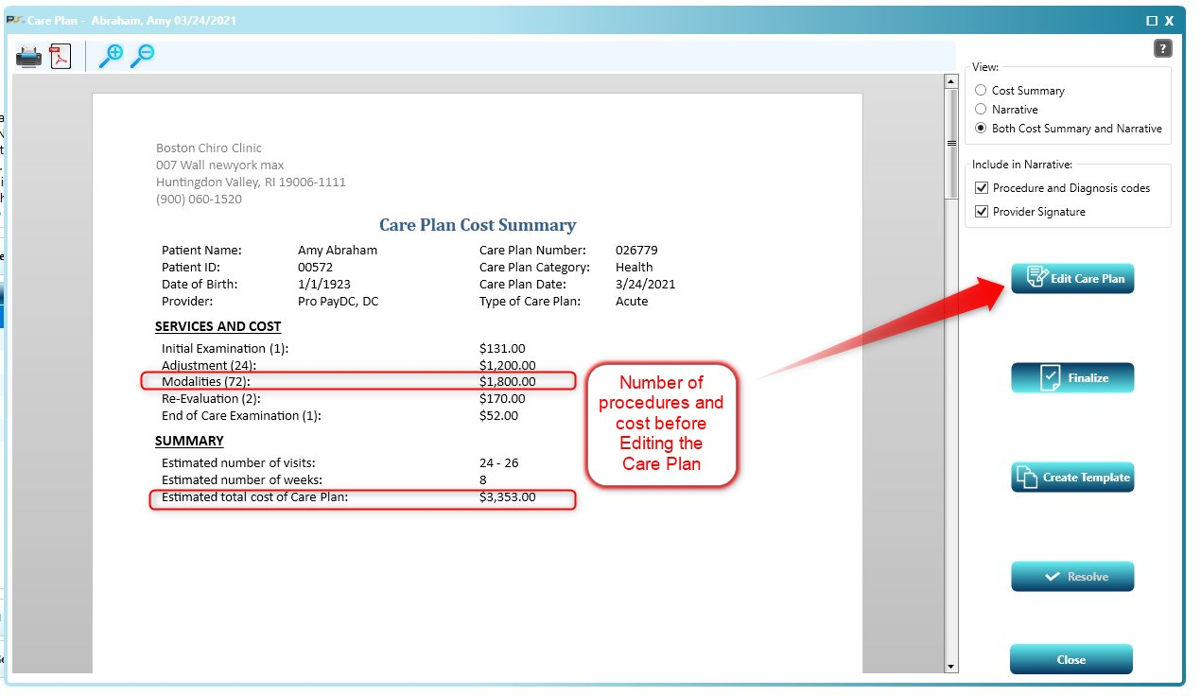

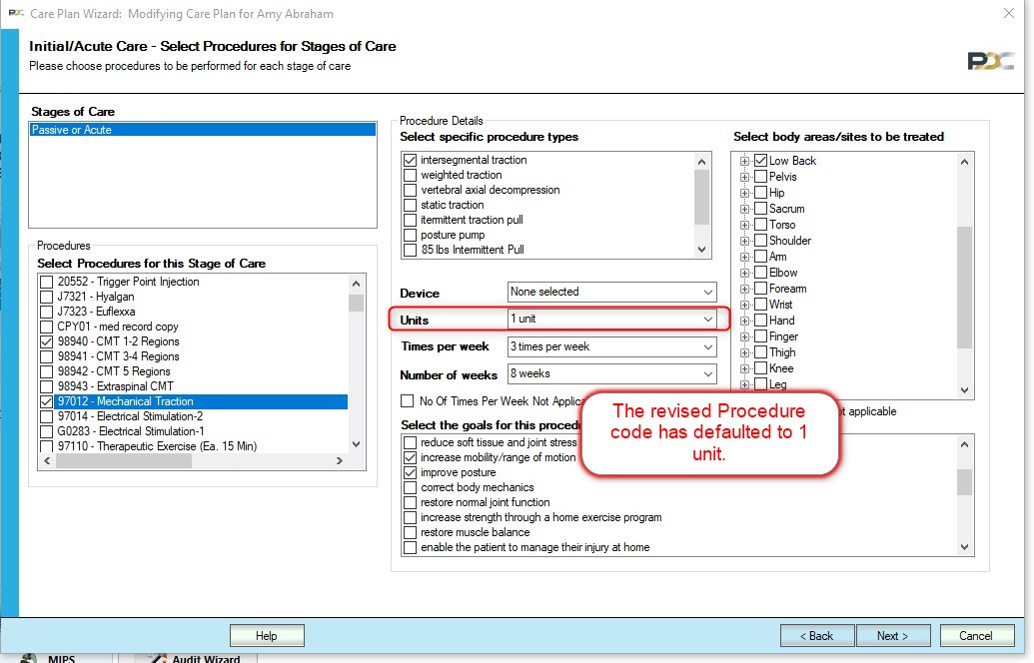

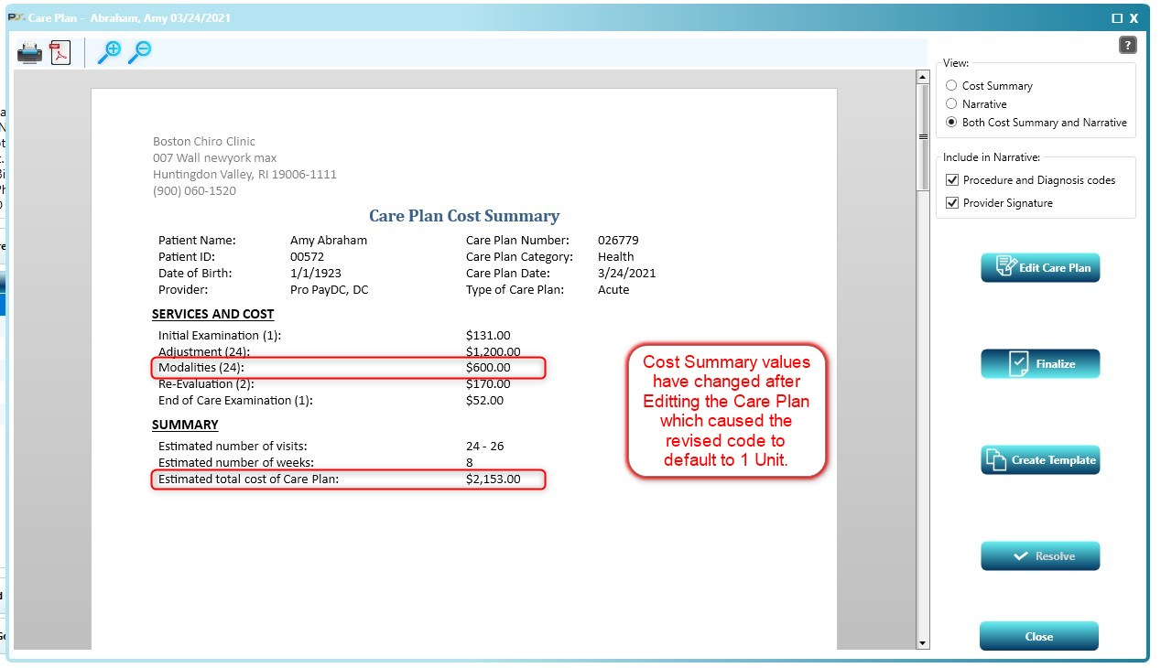

Advanced Settings: Added verbiage noting which aspects of Procedure Codes may now be modified:

Some columns for procedure codes that have already been used in SOAP Notes and Care Plans cannot be changed, such as Include, In-House Code, Display As (CPT), and POS code. Also, please note that many procedure codes should not be checked in either the Time Based or Unit Based columns.

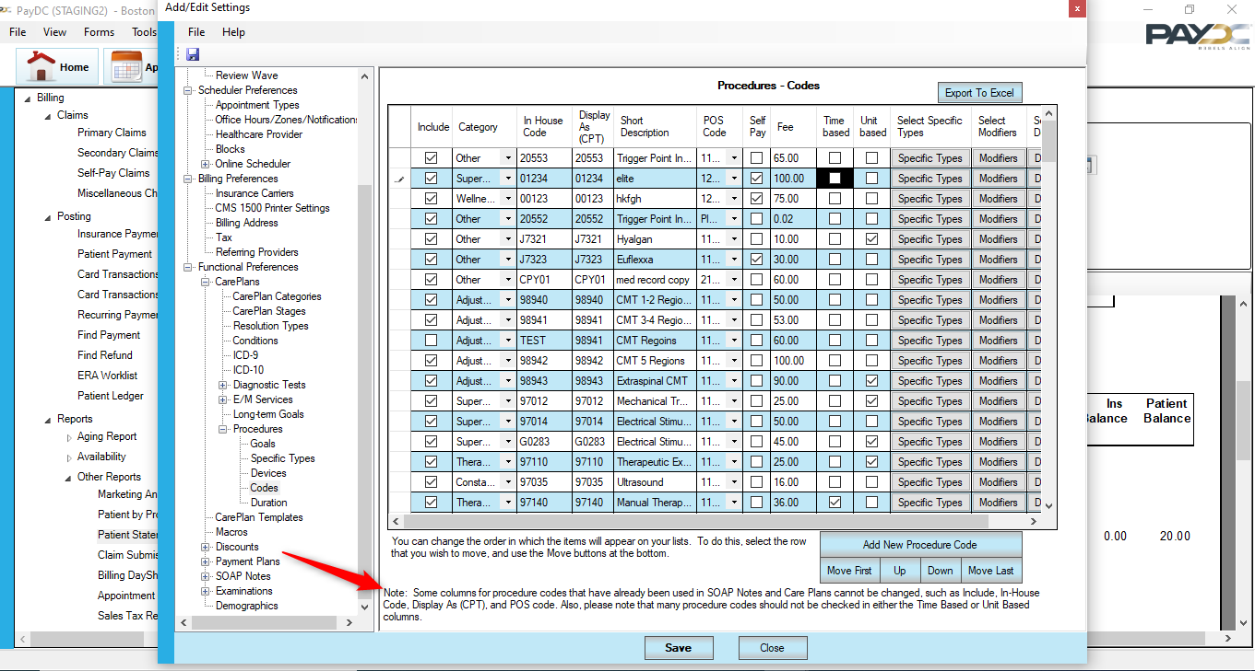

Integrated Merchant Services: Added feature for Cash Practice accounts to default the payment method drop-down to Virtual Terminal in Patient Payment and Insurance Payment screens for the logged in providers.

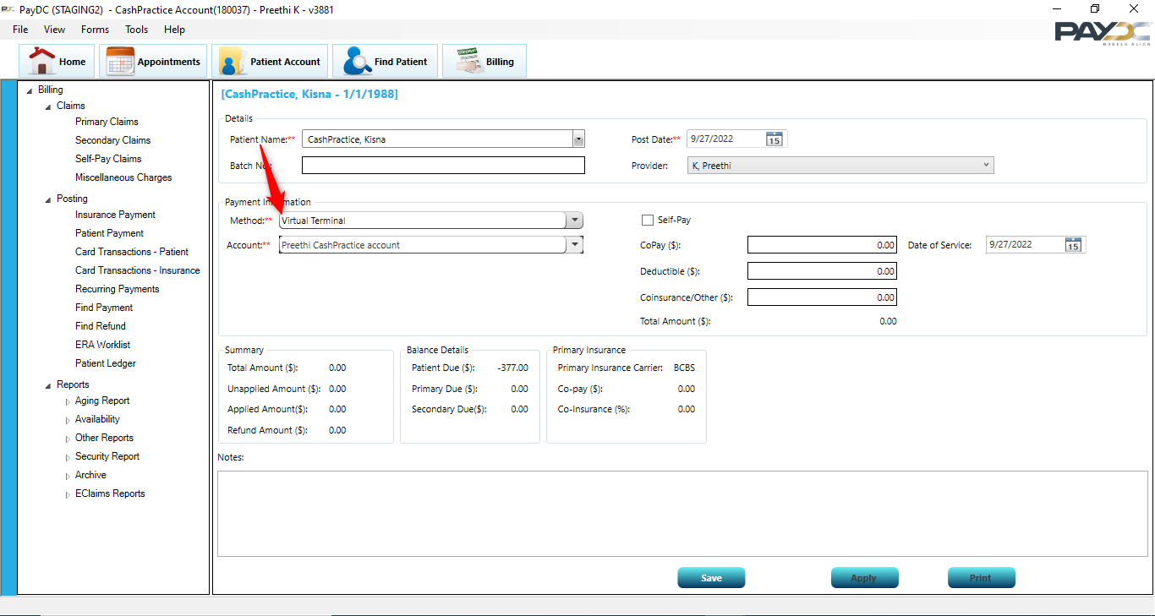

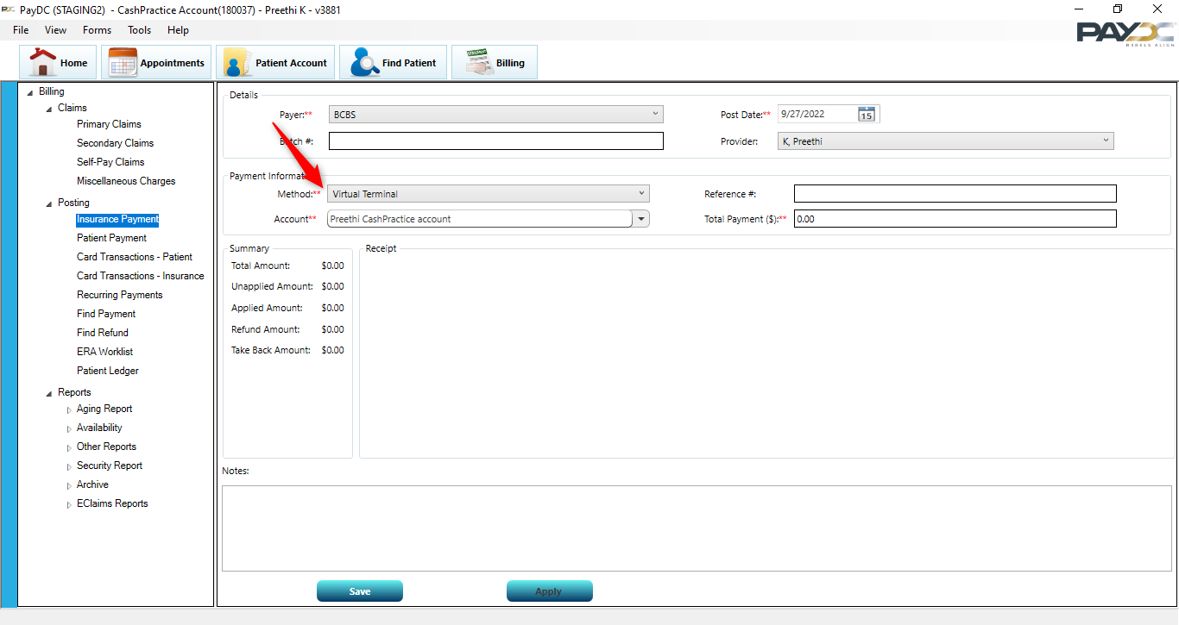

Thank you for trusting us as your software vendor!

Questions? You can always ask our Service Desk.
- If you are a PayDC customer, the phone number is (888) 306-1257; please choose option 4 for Service Desk.
- If you are an Advanced Provider Solutions customer, the phone number is (855) 283-4940; please choose option 4 for Service Desk.
- If you would like to contact the Service Desk via e-mail, please use the Contact Us form on our website. Please note: The Contact Us form is now secure, so you can include PHI in your description.

