See What's New from PayDC!
Here’s what’s in this Release (August 29, 2022)
In order to effectively communicate your patient's condition and symptoms in a uniform way, several areas in our Patient Demographics and Patient Portal have been consolidated and replaced with the comprehensive Review of Systems found in the ROS button of the SOAP Notes screen. Now your patients will be able to list the same information that is available to the providers.
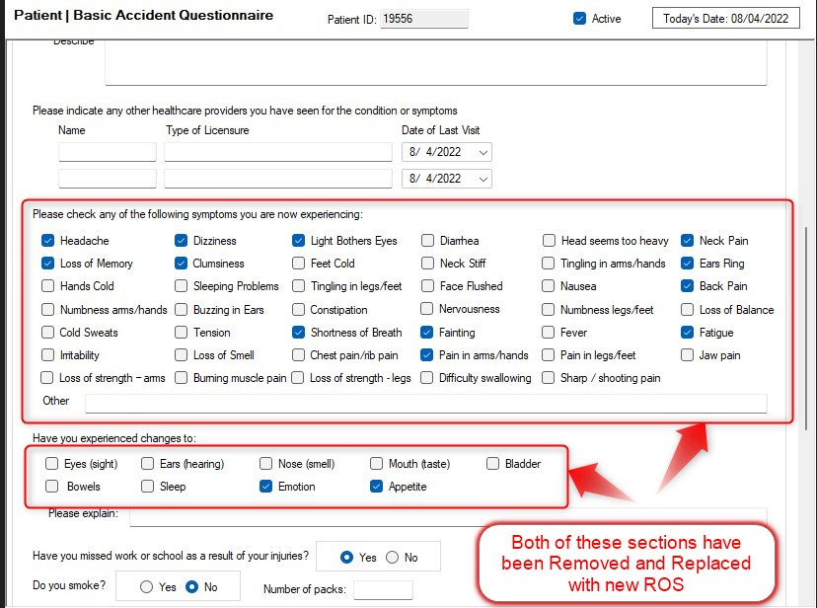

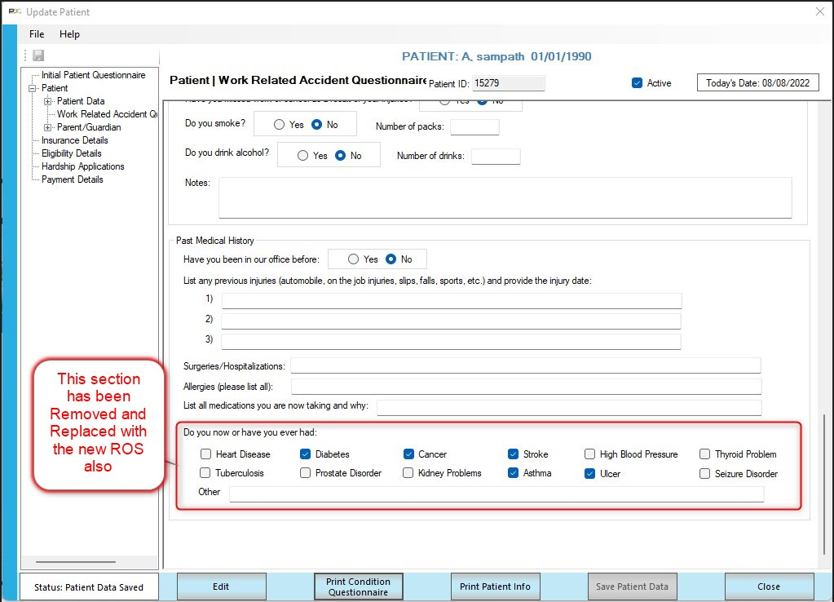
Any information contained in those sections has been archived and is accessible by opening the archived questionnaire and then clicking “Print Condition Questionnaire”
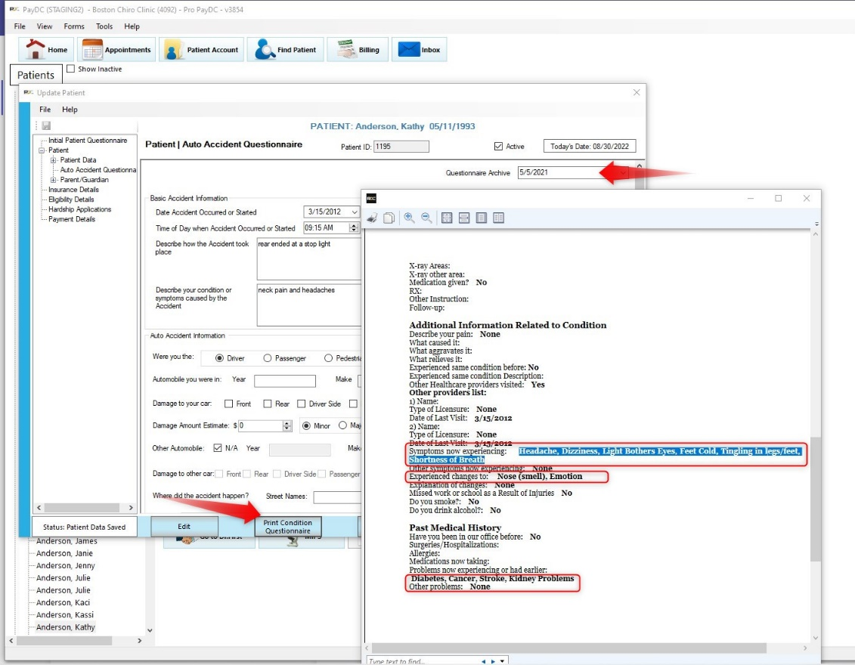
You’ll now find the Review of Systems (ROS) list in its own section of the Patient Demographics: 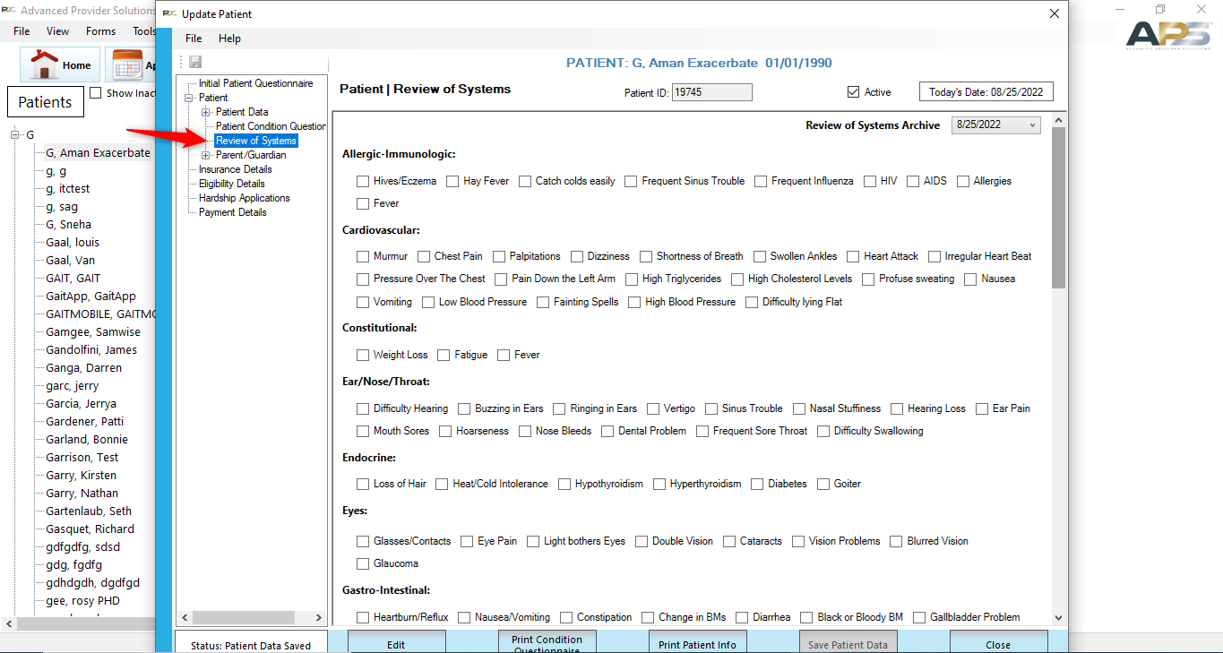

Patients can complete the ROS questionnaire through the Patient Portal. All selected symptoms will import automatically into the patient’s account.
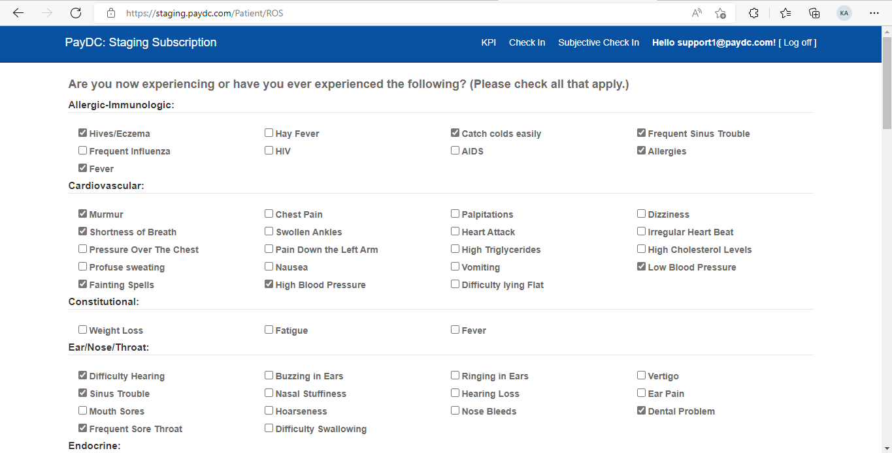

Selected symptoms will be displayed in the printed Condition Questionnaire as well as the SOAP Note screen: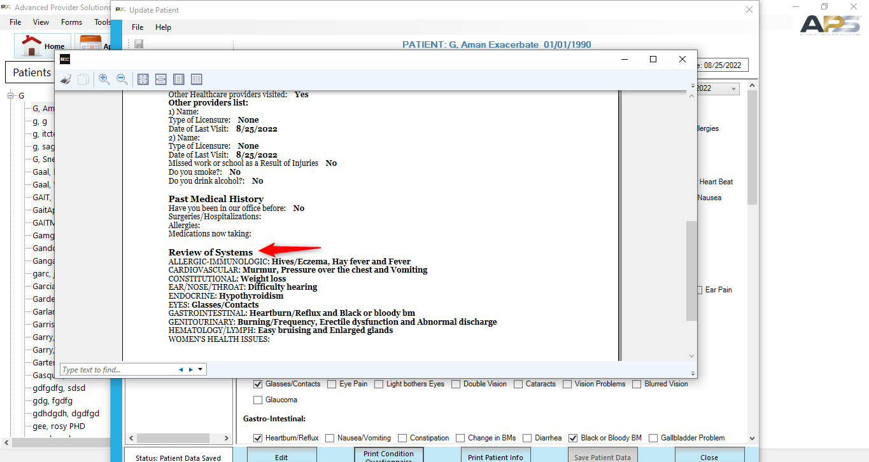 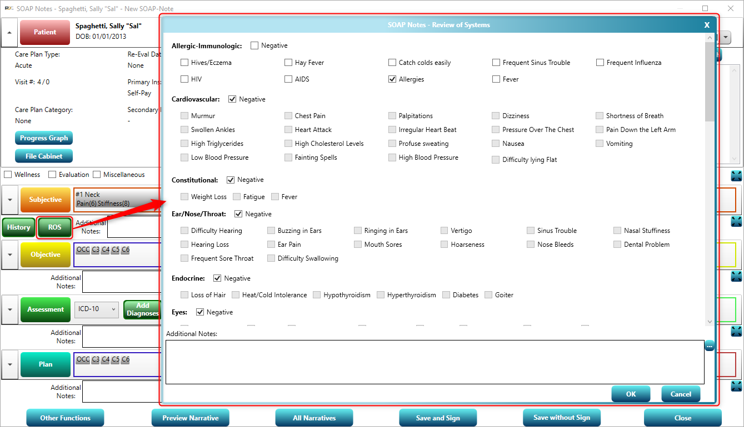

Making a new selection in the “Condition Related to” section in Initial Patient Questionnaire will auto-archive the current Review of Systems and generate a new ROS to be completed. 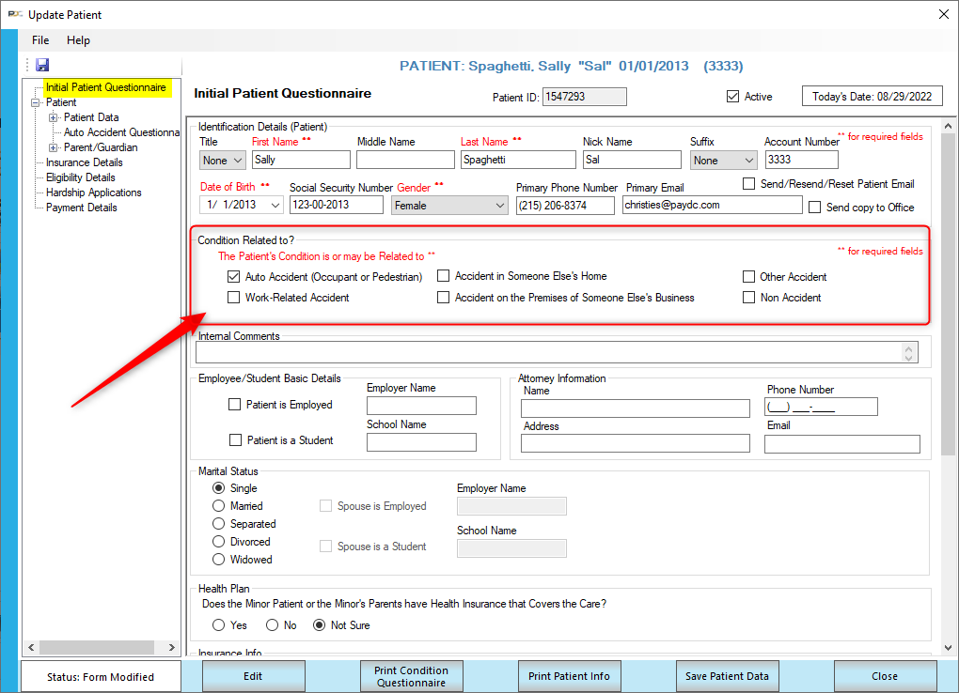
Just like archived Condition questionnaires, archived ROS are accessible in the top- right corner of the demographics screen.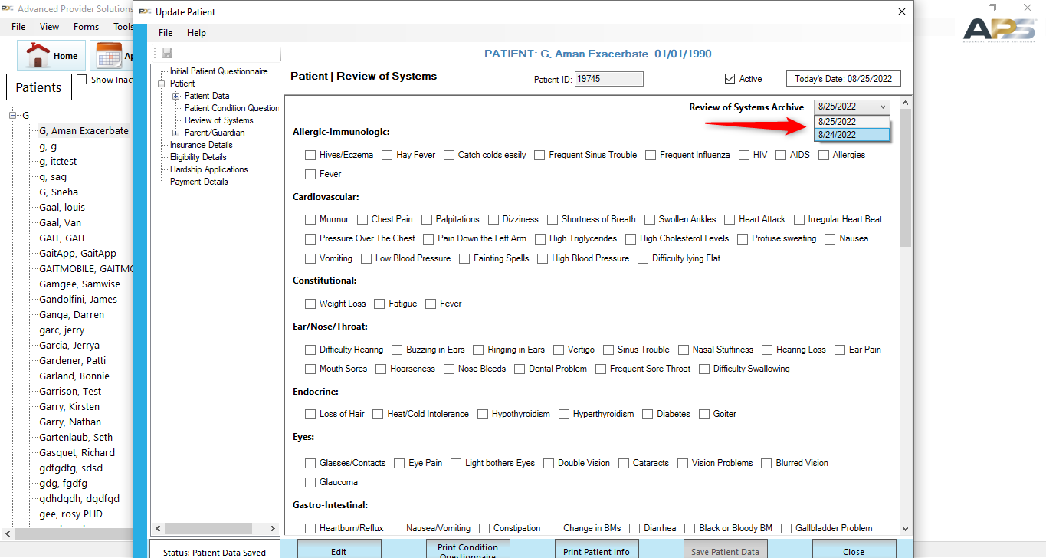

In SOAP Note > ROS screen, if “Negative” checkbox is selected then that specific category options will be disabled and to enable those options, users need to uncheck the Negative checkbox.
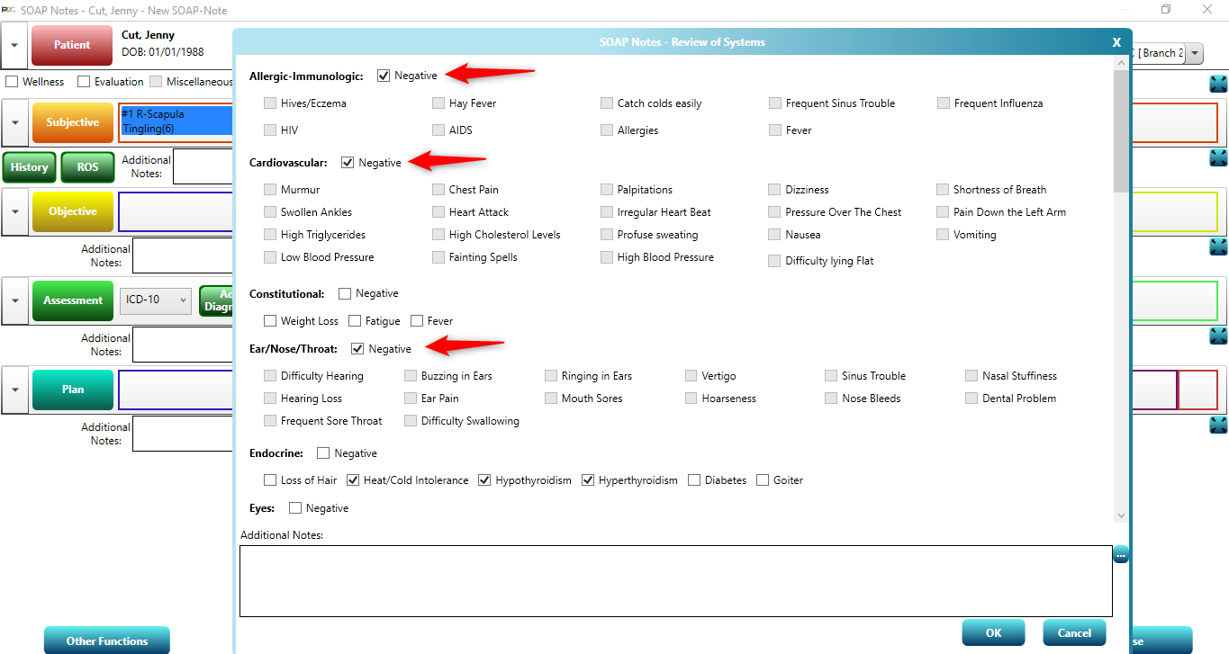
Added the following new options to General section of ROS.
- Metal
- Rods
- Pins
- Screws
- Staples
- Any type of Metal Beneath Skin
Added the following pain types in Patient Questionnaires in Patient Demographics and Patient portal to match those available in the Subjective tab of the SOAP Notes screen.
- Radiating
- Throbbing
- Numbness
- Stabbing

Thank you for trusting us as your software vendor!

Questions? You can always ask our Service Desk.
- If you are a PayDC customer, the phone number is (888) 306-1257; please choose option 4 for Service Desk.
- If you are an Advanced Provider Solutions customer, the phone number is (855) 283-4940; please choose option 4 for Service Desk.
- If you would like to contact the Service Desk via e-mail, please use the Contact Us form on our website. Please note: The Contact Us form is now secure, so you can include PHI in your description.

